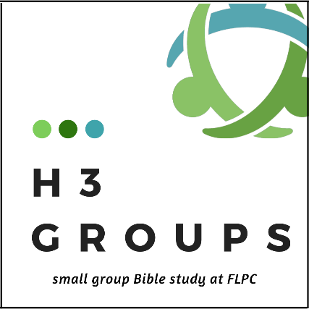
FAQ

What are H3 Groups?
H3 Groups are Bible study small groups designed to study Scripture, pray and hopefully share a meal together with the same group of folks (12 people or fewer). The title, H3 represents “Head, Heart and Hands in the Service of Christ.”

Why should I sign up for this? My life is busy enough!
We hear you and understand. In the Covenant Bible Study, you will learn how to love God, and each other, better. You’ll grow by practicing conversation about Scripture and relationships in a group. You’ll change by being accountable to a group of friends and fellow disciples. You’ll discover your unique identity and purpose through Scripture. You share by belonging to a group of friends in faith. You’ll serve by responding to what you learn. And hopefully, we’ll all become better, more loving versions of ourselves!

When will the groups meet?
You will be grouped with people who have requested the same general meeting time as you and the group can decide together your group’s exact meeting day/time.

What if my group meets at a time that doesn’t suit me?
We will work to find another group for you that is convenient.

How long is each meeting time?
We suggested planning 90 minutes to two hours for your Covenant meeting time. But that will ultimately be up to the group.

Will it cost anything?
You will want to purchase a participant book for $15. There is an optional meditations book you may also want to purchase for $10. If you are in the market for a new Bible, the Common English Bible is recommended. We will have those for purchase for $28.

What if I miss a week? Can I continue without falling behind?
Yes, please continue! It’s ideal to keep up with your Scripture readings but we all know life happens and interrupts our plans. Just continue on!

Will childcare be offered?
Yes - for any group that wants to meet on Wednesday nights from 6:15-7:45. We are also working to provide childcare at the church on one other night per week (this depends on the requests of groups). However, if your group meets on a night when childcare is not offered at FLPC, you will be responsible to provide your own. Call us if this is a problem. We want to eliminate barriers to your participation.

Do we have to eat a meal together?
No. That is up to the group to decide. We recognize food brings people together, and encourage you to do so, but that decision is up to the group.

Will there be Disciple Bible study at FLPC this fall?
We have offered the Disciple Bible study series for many years. We felt it was time for a change, so Covenant Bible Study will replace Disciple this fall. For other Bible Study options please see our Education Newsletter on our website.

Do I have to recruit my group?
No – just register and we will put you in a group.

Can I recruit my own group?
Yes, sure! Just let us know who will be in your group.

Can I invite someone to join my group who doesn’t go to this church?
Absolutely! Anyone is welcome to sign up for H3 Groups.

For more information contact Jodi Beckham, jodibeckham@flpc.org. To register, please go to flpc.org/happenings/events.

